**Vikas Public Sec. School ,Keharpura kalan**

**NURSARY (WORK SHEET)**

Draw a line to match the latter with the picture that begins with it and colour the picture .

C 

A 

B 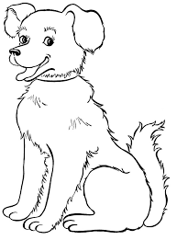

D 

**Vikas Public Sec. School ,Keharpura kalan**

**NURSARY (WORK SHEET)**

**Draw a line to match the latter with the picture that begins with it and colour the picture .**

C 

A 

B 

D 